Development Proposal for

## HT6C

**Updated 1-Dial Hose-Bib Timer**

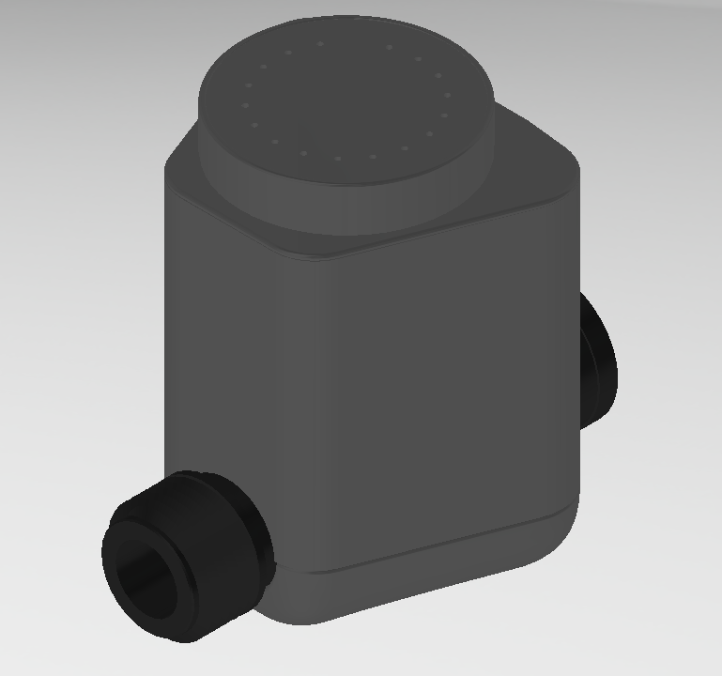

CONTENT

1 General Specification 3

1.1 Description- Timer 3

2 Physical Specification 4

2.1 Body 4

2.2 Dial Selector 4

2.3 Valve Specification 4

3 Electrical Specification 5

3.1 Timer 5

3.2 Standards 5

4 Environmental Specification 5

4.1 Operating humidity: 90% RH 5

4.2 Operating ambient temperature: 0 to 50 **°**C 5

4.3 Storage temperature: -10 to 60 **°**C 5

4.4 The PCB should be conformal coated. 5

5 Functional Specification 6

5.1 Power up/Battery Installation – When the unit is powered up. 6

5.2 Setting the Watering Cycle and Duration 6

5.3 OFF Mode 6

5.4 ON Mode 6

5.5 Reinforcement ON Pulse 7

5.6 Reinforcement Off Pulse 7

5.7 Changing the Program Settings 7

5.8 Low Battery Detection 7

5.9 Test Mode (for factory use) 7

6 Operating Rule 8

6.1 To operate the valve using the desired watering cycle and duration 8

6.2 To turn on the valve permanently 8

6.3 To manually turn off the valve 8

7 Revisions 9

2. Project Objectives
   * 1. Update the appearance of the HT6 Valves
     2. Improve water resistance
     3. Substantially reduce the total cost of the timer
3. General Specification
   1. Description- Timer
      1. A compact programmable timer for controlling hose-bib watering.
      2. One rotary dial for setting watering cycle and watering duration.
      3. One RGB LED visible through the dial.
      4. All logic, timing and switching is powered by two replaceable 1.5V AA size alkaline batteries.
      5. Three kinds of operating modes: ON, OFF, and specified watering interval and duration.
      6. Sixteen watering cycle and duration options.
      7. A latching solenoid is used to open or close the diaphragm valve.
      8. Timer shall retain the valve

1. Physical Specification
   1. Body
      1. Max Dimensions: 3.0 in x 3.75 in. x 3.0 in.
      2. Housing, Dial, and Battery tray made of ABS + UV
      3. Water resistant to IPx5 requirements per IEC 60529.
         1. 1 minute of testing targeting each likely point of ingress. Total test duration shall be a minimum of 3 minutes.
         2. Pass criteria: No water entry into electronics/battery chambers of assembly.
   2. Dial Selector
      1. Diameter: 2 in
      2. Dial for setting watering cycle and watering duration
      3. Eighteen positions around the dial:
      4. Interval Timer position functions:
         1. ON Valve OPEN, watering begin
         2. OFF Valve CLOSE, stop watering
         3. DAILY 3 min Watering 3 minutes every day
         4. DAILY 5 min Watering 5 minutes every day
         5. DAILY 10 min Watering 10 minutes every day
         6. DAILY 15 min Watering 15 minutes every day
         7. DAILY 30 min Watering 30 minutes every day
         8. DAILY 60 min Watering 60 minutes every day
         9. EVERY OTHER DAY 5 min Watering 5 minutes every other day
         10. EVERY OTHER DAY 10 min Watering 10 minutes every other day
         11. EVERY OTHER DAY 15 min Watering 15 minutes every other day
         12. EVERY OTHER DAY 30 min Watering 30 minutes every other day
         13. EVERY OTHER DAY 60 min Watering 60 minutes every other day
         14. EVERY 3rd DAY 10 min Watering 10 minutes every 3rd day
         15. EVERY 3rd DAY 15 min Watering 15 minutes every 3rd day
         16. EVERY 3rd DAY 30 min Watering 30 minutes every 3rd day
         17. EVERY 3rd DAY 60 min Watering 60 minutes every 3rd day
         18. EVERY 3rd DAY 90 min Watering 90 minutes every 3rd day
      5. LED Position indicator in the surface of the dial.
      6. Physical detent at each position.
      7. Dial shall self-center into each detent when released.
   3. Valve
      1. The HT6X Hose Bib Valve with a plastic swivel or equivalent.
2. Electrical Specification
   1. Batteries
      1. Battery: 2 x 1.5V AA size alkaline batteries

(Assume battery capacity is 2850 mAh)

* + 1. Battery life: 1 year

(Assume the Interval timer is operating at the mode of DAILY 3 min.)

(Assume the duration timer is operating 3x daily for 30 minutes)

* 1. PCBA
     1. Conformal Coated
     2. Time Accuracy ±2.0 E-6 Seconds
  2. Standards
     1. Unit to pass EMI/EMC test according to CE.
     2. C-Tick

1. Environmental Specification
   1. Operating humidity: 90% RH
   2. Operating ambient temperature: 0 to 50 °C
   3. Storage temperature: -10 to 60 °C
2. Functional Specification
   1. Power up/Battery Installation – When the unit is powered up.
      1. When new batteries are first installed, an OFF pulse will be sent to the valve.
      2. All setting in program are cleared.
      3. The timer begins with mode of operation in accordance with the rotary dial setting and the watering cycle timing begins immediately.
   2. LED Indication.
      1. Dial in “OFF” position: LED is always off.
      2. Power up: LED is solid white for three seconds at any dial position except OFF.
      3. Low Battery Indication: LED flashes red 0.1 sec at 1.5 Hz for 2 seconds at 1 minute intervals during watering events and on entering a new dial position. (interval timer only)
      4. OFF.
      5. Dial rotation: LED is solid white for two seconds on entering a new dial position or until a dial position change is detected.
      6. Valve open: LED flashes blue or white 0.333 sec at 1.5 Hz for two seconds prior to opening the valve.
      7. Rain Delay on: LED flashes green 1 second at 0.0333 Hz when Rain delay is active. (interval timer only)
      8. Activate Rain Delay: LED flashes green 0.5 second at 1 Hz for 5 seconds just before rain delay is turned on. (interval timer only)
   3. Setting the Watering Cycle and Duration
      1. Rotate the dial to the desired watering cycle and duration.
      2. After a 4 second delay, the new watering cycle and duration begins immediately.
      3. When the scheduled watering cycle time is reached, an ON pulse will be sent to the solenoid and the valve will stay ON for the specified duration.

However, ON pulse will not be sent if the valve is already ON or OFF mode is activated. Once the watering duration is finished, an OFF pulse will be sent to the solenoid.

* + 1. If a new cycle and duration setting occurs during the watering period, the new watering cycle and duration should start immediately and the valve should remain ON for the new specified duration.
  1. OFF Mode
     1. OFF Mode immediately stops watering and clears previous water program after 5 seconds.
     2. To enter OFF mode, rotate the dial to the “OFF” position.
     3. When the dial is rotated to the “OFF” position, the timer will immediately send an OFF pulse to the solenoid to close the valve.
     4. After dial has remained in the “OFF” position for 5 seconds, the current watering cycle is cleared.
     5. Rotate the dial from “OFF” to any desired value (e.g. DAILY 30min.) will terminate the OFF mode. The timer will water for the specified duration at the time of day the selection was made. And the timer will water again in the next specified watering cycle for the specified duration.
     6. Rotate the dial to “ON” will terminate the OFF mode and enter the ON mode after a 4 second delay.
  2. ON Mode
     1. On Mode turns the water on until it is exited.
     2. To enter ON mode, rotate the duration dial to the “ON” position and leave the dial in the “ON” position for 4 seconds.
     3. Upon entering ON mode, the timer will send an ON pulse to the solenoid to open the valve and the valve will stay ON until the dial is turned to another position.
     4. Current watering cycle and the scheduled watering cycle are not changed by entering ON mode.
     5. To exit ON mode rotate the dial from “ON” to another position. The timer send an off pulse to the valve when exiting ON mode.
  3. 24 Hour Rain Delay Mode (Interval Timer Only)
     1. Rain Delay prevents scheduled waterting from starting during delay.
     2. To enter Rain Delay mode, rotate the dial 1 position counter-clockwise, 1 position clockwise, and leave the dial alone for 5 seconds while the LED flashes green.
     3. After entering Rain Delay mode, Timer will not send any ON pulses to the valve. LED will flash green once every 30 seconds.
     4. Rain Delay mode automatically exits 24 hours after starting.
     5. Rotating the dial will cancel rain delay mode.
  4. Reinforcement ON Pulse
     1. Whenever an ON pulse is sent to the valve, a reinforcement ON pulse will be sent 10 seconds later if the dial is left in the same position.
  5. Reinforcement Off Pulse
     1. When the timer completes a timed watering cycle, an OFF pulse will be sent to the valve and 10 seconds later another reinforcement OFF pulse will be sent.
     2. When the dial is rotated to the “OFF” position an OFF pulse will be sent to the valve. If the dial is left in the “OFF” position, another reinforcement OFF pulse will be sent 5 seconds later.

* 1. Changing the Program Settings
     1. When the rotary dial is rotated to a position other than the current program and left for more than 4 seconds, the timer will clear the previous program, set the new one and immediately begin watering.
     2. Rotating the dial to any position other than OFF will not change the watering cycle settings until the start of new program.
  2. Low Battery Detection
     1. When the input voltage level is below 2.6 V, LED will begin low battery indication. (interval timer only)
     2. When the input voltage level is below 2.5 V, an OFF pulse (with reinforcement) will be sent to the valve and low battery indication will stop.
     3. Once 2.5 V threshold has been crossed, the timer will stop and reject all the normal operations, but will keep detecting the battery level every 8 seconds until new batteries are installed.
     4. When new batteries are installed, if the input voltage is detected to be above or equal to 2.8. V the timer will reset and resume normal operation. Otherwise, the timer will continue to reject normal operations.

1. Operating Rules
   1. To operate the valve using the desired watering cycle and duration
      1. Rotate the dial to the desired watering cycle and duration. The valve will open and watering will begin immediately for the specified duration.
      2. The next watering will start according the specified cycle.
      3. Rotate the dial to the new watering cycle and duration, current watering cycle and duration will exit. Watering will begin immediately according to the new watering duration and the next watering will start according to the new specified cycle.

* 1. To turn on the valve permanently
     1. Rotate the dial to the ON position. The valve will open and watering will begin immediately.
     2. Watering will not stop until dial is moved to another position.
  2. To manually turn off the valve
     1. If the timer is set to operate the valve using the desired watering cycle and duration, rotate the dial to the OFF position will stop the timer and the valve will shut off.
     2. If the timer is in the “ON mode”, rotate the dial clockwise to the OFF position will shut off the valve.